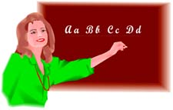
Let’s have fun!
Pronunciation Board Game
Say it right!
33.


32.

34.


31.


30.


29.
Go back 5 spaces
35.
Start again

36.
Finish
26.


27.

28.


18.


20.


24. Start again

23.


22.


21.


9.
Start again

13
Go forward 3 spaces

14. 

15.


16.


25.
Go forward 3 spaces
19.


17.


1.
Start
8. 

7.


6.
Go back 3 spaces
11.


12.

5.


10.


2.


3.


4.


Vowels





















Consonants























g

How to play

Roll the dice and advance according to the number that shows on the dice. When a player lands on a space s/he has to decode the phonetic symbol first by reading the word and then by trying to spell the word. If correct, the player advances after the other player has taken a turn. If wrong the player looses a turn . If a player lands on a box with instructions, s/he follows the instructions. If the instruction is – START AGAIN, the player goes back to start. If it is GO FORWARD, s/he advances according to the instruction. The first person to get to finish wins.

